**15-112: Principles of Programming and Computer Science**

**Final Project Proposal : Dots and Boxes game**

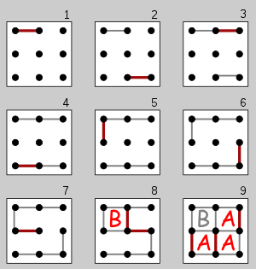

**Project Description:**

Dots and Boxes is a classic two-player game, starting with an empty grid of dots, each player chooses a line color and takes turns in drawing a line between two dots, avoiding giving away boxes, as well as aim to make the most boxes. When a player makes a box, their name appears inside it, and they get another turn. The game ends when the grid is full, and the player with the most boxes wins. The game will allow the player three options, play offline, play against AI, or against another player online over the 15112 server.

*Source:*[*https://en.wikipedia.org/wiki/Dots_and_Boxes*](https://en.wikipedia.org/wiki/Dots_and_Boxes)

**Libraries to be used:**

* Socket – to connect over the network.
* Random – to randomize color choices.
* Tkinter – for the user interface of the project.
* Pygame – to set up the game interface.
* Other libraries for functionality of AI or other features.

**Description of the user interface:**

1. The game will start by loading a window with three options, play offline with a friend, offline against the computer or play online with a friend.
2. If they choose to play offline with a friend, the window will display an instructions page, once done it will ask for names and give color options, then start the game.
3. If they choose to play against the computer (single player), then the interface will load an instructions page, once done, a window will ask for a name and a color choice, then load the game with a randomized name and color to represent the computer.
4. If the player chooses to play online with a friend, a login page then a main screen showing a list of friends, users and requests. The player will select a friend, then the window will load an instructions page, once done, a window will ask for color options and then load the game.
5. The game will be a grid of dots, the player would click between two dots and a line will be animated between the dots. There will be a counter of boxes for each player on top of the game interface.as well as an indicator of who’s turn it is.
6. Once the game ends a window will appear to show the player’s win or loss, and the choice to exit or return to the main menu (if it is online, it will return to the server window, the server window will have the option to return to the game options page).

**Set of features by first milestone date:**

For the first milestone, I will set up the graphical interface for the Menu and the game window, allowing the user to play with a friend offline for now. I will also establish a connection and set up the login and main screen windows.

**Other features for the final submission:**

The player will be able to play on the server and against the computer. The artificial intelligence will be implemented using the minimax algorithm, which would find all the decisions the computer can take to win (or minimize loss), and the alpha beta-pruning algorithm will minimize the search of the minimax algorithm (making it faster).